<https://studybreaks.com/culture/fast-fashion/>

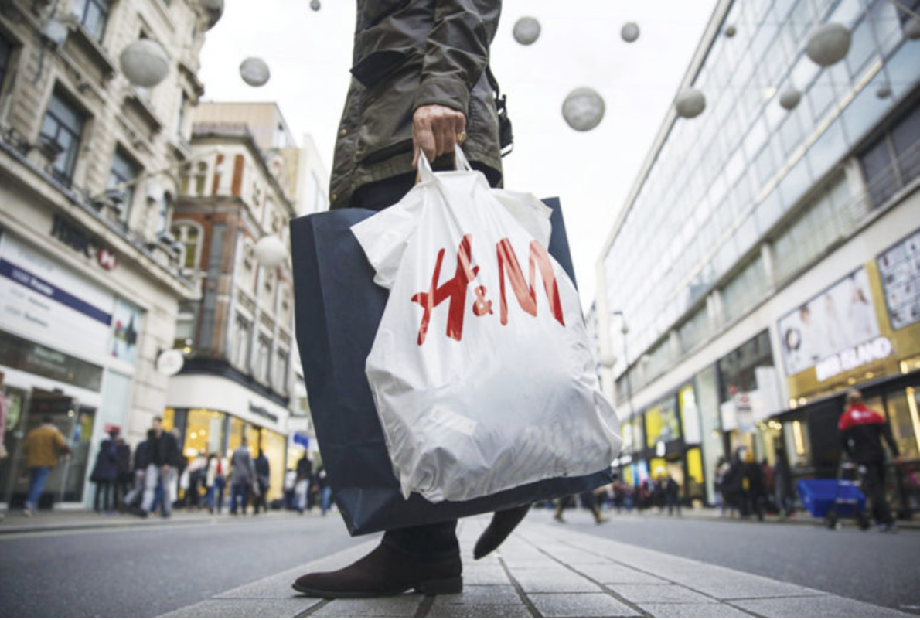

* Shows H&M which I talk about being a fast fashion brand.
* <https://github.com/nisteven-su/ist263/blob/main/Media/h%26m.png>

<https://www.nytimes.com/2019/12/17/style/fast-fashion-gen-z.html>



* Shows the demographic of fast fashion. Young college students that want cheap and trendy clothing for social media
* <https://github.com/nisteven-su/ist263/blob/main/Media/college.png>

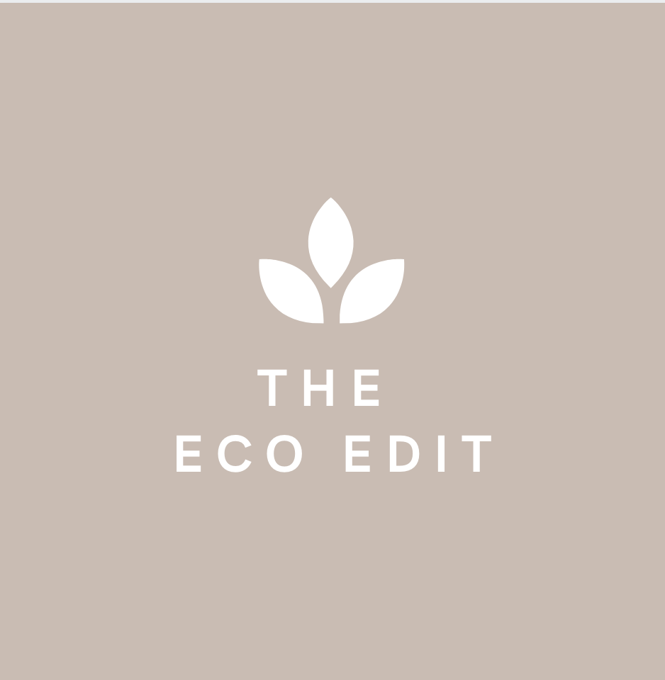

* Logo for my website
* <https://github.com/nisteven-su/ist263/blob/main/Media/logo.png>



* A picture of me for the bio
* <https://github.com/nisteven-su/ist263/blob/main/Media/bio.png>

<https://www.youtube.com/watch?v=YOA0D0i5-fA>

* The video talks about the environmental effects of fast fashion.

<https://fortune.com/2016/11/16/neiman-marcus-rent-the-runway/>

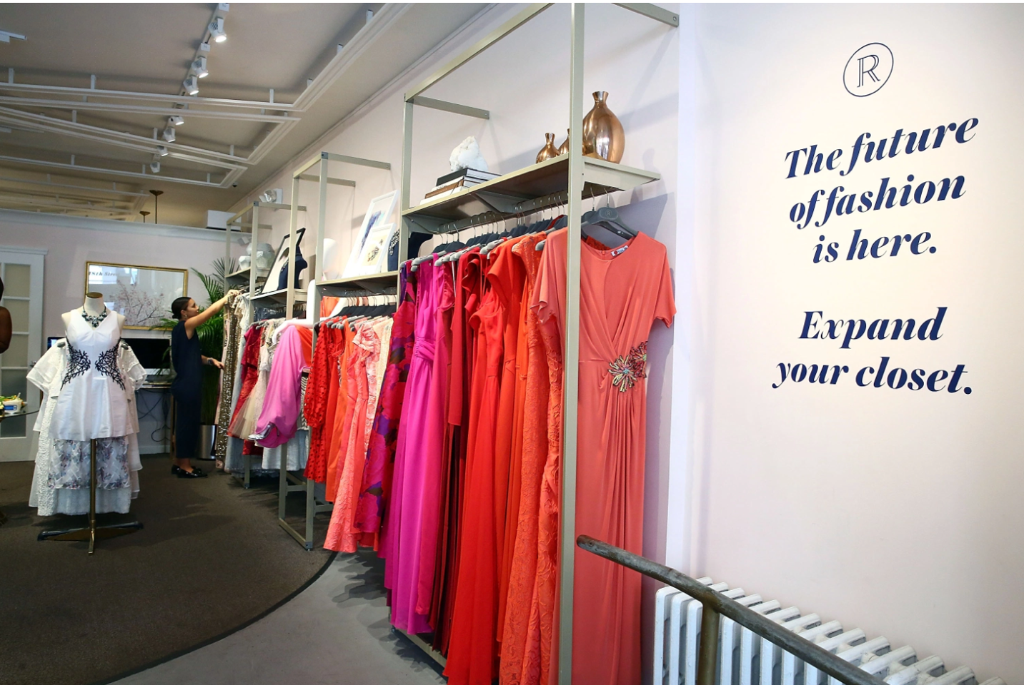

* I use the brand Fast Fashion as an alternative way to get trendy clothing without harming the environment.
* <https://github.com/nisteven-su/ist263/blob/main/Media/renttherunway.png>

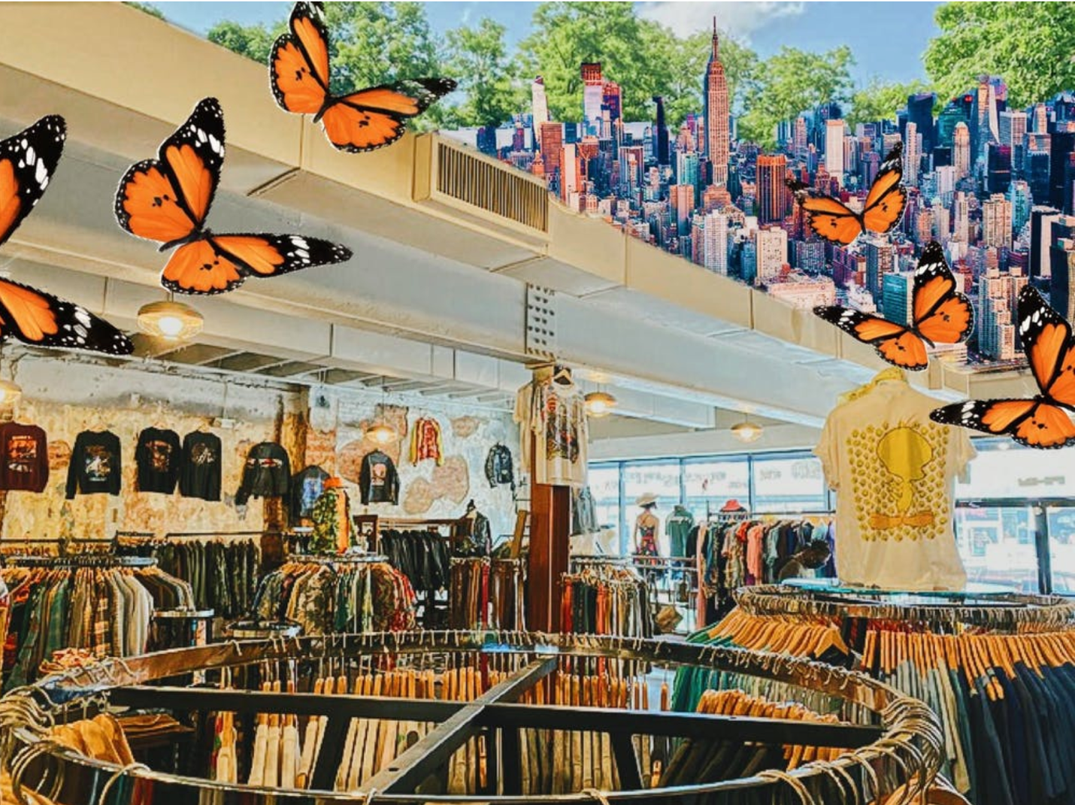

* A picture of a thrift store that I use as an alternative way to shop.
* <https://github.com/nisteven-su/ist263/blob/main/Media/thrift.png>

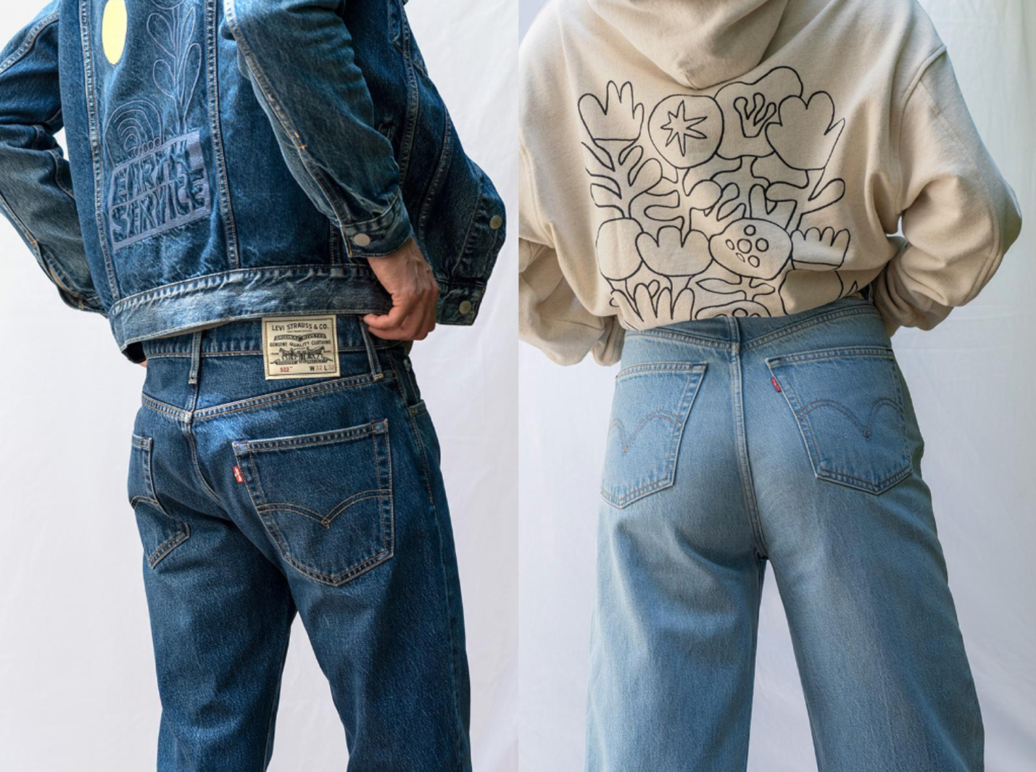

<https://www.greenqueen.com.hk/levis-launches-most-sustainable-jean-yet-made-with-circulose/>

* I mention how Levis is a sustainable friendly brand to shop for. This is one of Levi’s advertisements of their sustainable jean line.
* <https://github.com/nisteven-su/ist263/blob/main/Media/levis.png>

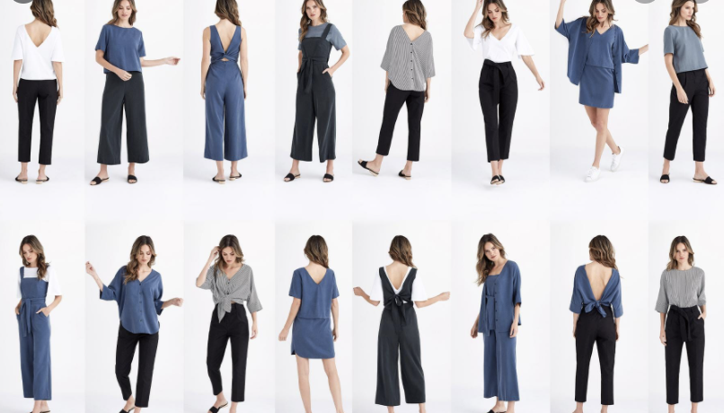

<https://www.fodors.com/news/photos/these-versatile-travel-clothes-will-get-you-through-your-entire-vacation>

* I also give a tip for versatile clothing. This is the picture that would be associated for this section.
* <https://github.com/nisteven-su/ist263/blob/main/Media/versatile.png>